**Chapter 4**

**Differentiation of Functions of Several Variables**

**4.2 Limits and Continuity**

**Section Exercises**

**For the following exercises, find the limit of the function.**

61. 

Answer: 2.0

**For the following exercises, evaluate the limits at the indicated values of . If the limit does not exist, state this and explain why the limit does not exist.**

63. 

Answer: 

65. 

Answer: 

67. 

Answer: 

69. 

Answer: 

71. 

Answer: 

73. 

Answer:

75. 

Answer:

77. 

Answer: The limit does not exist because when  and  both approach zero, the function approaches  which is undefined (approaches negative infinity).

**For the following exercises, complete the statement.**

79. A point  in a plane region  is called a boundary point of  if ___________.

Answer: every open disk centered at  contains points inside  and outside 

**For the following exercises, use algebraic techniques to evaluate the limit.**

81. 

Answer:

83. 

Answer:

**For the following exercises, evaluate the limits of the functions of three variables.**

85. 

Answer: The limit does not exist.

**For the following exercises, evaluate the limit of the function by determining the value the function approaches along the indicated paths. If the limit does not exist, explain why not.**

87. Evaluate  using the results of previous problem.

Answer: The limit does not exist. The function approaches two different values along different paths.

89. Evaluate  using the results of previous problem.

Answer: The limit does not exist because the function approaches two different values along the paths.

**Discuss the continuity of the following functions. Find the largest region in the -plane in which the following functions are continuous.**

91. 

Answer: The function  is continuous in the region .

93. 

Answer: The function  is continuous at all points in the -plane except at.

**For the following exercises, determine the region in which the function is continuous. Explain your answer.**

95. 

(*Hint*: Show that the function approaches different values along two different paths.)

Answer: The function is continuous at  since the limit of the function at  is , the same value of .

97. Determine whether  is continuous at .

Answer: The function is discontinuous at . The limit at fails to exist and does not exist.

99. Determine the region of the -plane in which the composite function  is continuous. Use technology to support your conclusion.

Answer: Since the function  is continuous over , is continuous where  is continuous. The inner function  is continuous on all points of the -plane except where  Thus,  is continuous on all points of the coordinate plane *except* at points at which .

101. At what points in space is  continuous?

Answer: All points  in space

103. Show that  does not exist at  by plotting the graph of the function.

Answer: The graph increases without bound as  both approach zero.

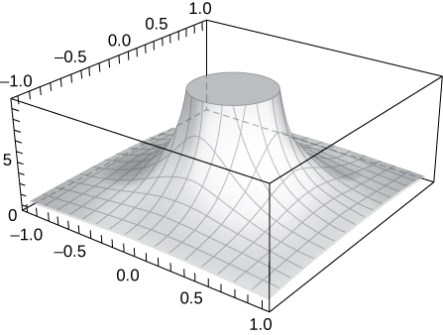

105. **[T]**

1. Use a CAS to draw a contour map of .
2. What is the name of the geometric shape of the level curves?
3. Give the general equation of the level curves.
4. What is the maximum value of ?
5. What is the domain of the function?
6. What is the range of the function?

Answer:

a.

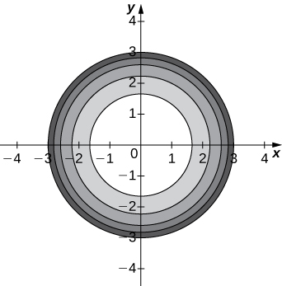

b. The level curves are circles centered at  with radius  c.  d.  e. f. 

107. Use polar coordinates to find . You can also find the limit using L’Hôpital’s rule.

Answer:

109. Discuss the continuity of  where  and 

Answer:  is continuous at all points  that are not on the line .

111. Given , find  .

Answer:

This file is copyright 2016, Rice University. All Rights Reserved.